**Part I: Read carefully with concentration each question and give short answer based on the question type. And write your answer on the provided space for each questions. Each have 1.5 points**

1. What is a left linear grammar?
2. What is right linear grammar?
3. What do you mean by Parsing?
4. What is meant by a useless production?
5. What is an ambiguous grammar?
6. Define PDA by the tuple.

**Part II: Workout**

**Write appropriate answerfor the following question on the space provided for each questions.**

1. Given *L*1 = {*a*, *ab*, *a*2} and *L*2 = {*b*2, *aba*} are the languages over *A* = {*a*, *b*}, determine (**4 Points**)
2. *L*1*L*2
3. *L*2*L*2.
4. Given a grammar G defined by the production rules as shown below.Show that the word w = a 2b4∊ L(G), where L is a language determined by G.(**3 Points**)

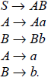

1. Determine the grammar that generates the set {0n1n n = 0,1,2, … }. (**2 Points** )
2. Determine the grammar for the languages which set of all bit strings containing an even number of 0s and no 1s.(**2 points** )
3. Determine a DFA that accepts all strings on {0,1} except those containing the substring 001.(**3 Points)**
4. Construct an NDFA for the state table given below. ( **2 Points**)

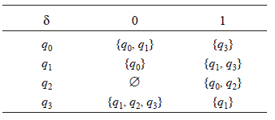

1. Obtain the language recognized by the NDA shown below.(**3 Points** )

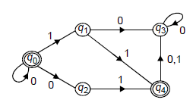

1. Determine the DFA that accepts the languageL(aa* + aba* + b* ).( **3 Points**)
2. Determine the regular expression for the languages accepted by thefollowing automata (**2 Points**)

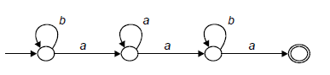

1. Determine a derivation tree of a * b + a * b given that a * b + a * b is inL(G) where G is given by the productions S ⟶S + S | S * S | a | b. (**3 Points** )
2. Let us consider the NPDA given by as shown below. Drawn the diagram for this NPDA(**2 Points**)



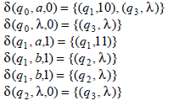

1. Obtain a grammar in Chomsky Normal Form equivalent to

S ⟶ aAbB, A⟶ aA| a, B⟶ bB | b. (**4 Points**)

1. Let us consider the NPDA given by definition below It is possible for us to recognize the string “aaabbb” (**2 Points**)

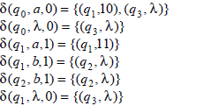

1. Construct a Push Down Automata (PDA) accepting {an bm an |m, n ≥1} by empty store.(**3 Points**)
2. Given a grammar *G* with production rules below Obtain the (i) leftmost derivation, and (ii) rightmost derivation for the string “*aaabbabbba*”.( **3 points**)

